The
Legend
of
Sphera

Design Document

Team Geotronics

Taumer Anabtawi, Jessica Kasson, Paul Kim
James Lowrey, Bob Tishma

Table of Contents

Overview | 3
Game Design | 3
Character Design | 4
Controls | 4
Stage 1 Design | 5
Stage 2 Design | 8
Stage 3 Design | 10
Stage 4 Design | 17
Stage 5 Design | 20
Credits | 23

Protagonist
Cubie, a small cube with big dreams.

Story
The Legend of Sphera is a platform and puzzle based game where our humble hero Cubie must overcome challenges and complete The Four Trials to win the heart of the beloved Princess Sphera. Legend has it that only a shape pure of heart and character is able to complete the trials. Many have tried, all have failed. The Kingdom of Shapeland is governed by a class system where a shape's place in society is dictated by the number of sides the shape has. Cubes are at the bottom with six sides. As this number rises, so does social status, with perfect spheres regarded as divinity. And while the only perfect sphere in Shapeland, Princess Sphera, has been adamant at ending this traditional system, her council of near-spheres, as well as most of the citizens of Shapeland believe what they have been told for ages is the only true way to govern. Our Hero Cubie however, aims to prove these shapes wrong. Cubie chooses to challenge this system and the ideology behind it and embarks on a journey to complete the Four Trials and drink from the Holy Waters needed to win Sphera's heart, proving that a shapes character isn’t defined by its sides, but by its volume.

Game Structure
The game features a main zone that the player will enter when they start a new game. Here, players can see the progress they have made building Cubie’s Sphere Machine while also viewing the different levels available for them to play. Portals that lead to the different levels are laid out along the perimeter of the main landing zone. Levels can be entered at any time and can be replayed multiple times.

Each level, while sharing many similarities, is designed to have it’s own independent feel to the aesthetics and gameplay functionality. This gives a variety to the game and can even be looked at as a single game consisted of several sub-games. Cubie’s challenges range from puzzlers to platforming but will always rely on logic and skill to complete. Each level increases in difficulty as the player progresses through them until Cubie collects all of the pieces of the machine and achieves his destiny. The player must complete four level to acquire the needed parts to build a machine and grant access to the fifth and final level.

Character Design
The main character is Cubie, a cube. The first four levels consist of moving cubie around to complete each level. While the movement uses the same keys across all levels, the actual motion and camera are specialized for each level with an emphasis on user playability. Each implementation uses key input to correlate to a transformation, force, torque, or a combination of these to move cubie. After completing the first four levels, cubie is transformed into a sphere to complete the final stage accompanied by an ending cutscene.

Controls

W | Move Cubie Forwards
A | Move Cubie Left
S | Move Cubie Backwards
D | Move Cubie Right
Up | Move Camera Forwards
Down | Move Camera Left
Left | Move Camera Backwards
Right | Move Camera Right
Space | Jump or Interact
Escape | Exit Level

Stage Design

Stage 1 - Bouncing ball dungeon
The first stage of the game has logic puzzles. The goal of this puzzle is to hit desired object (goal object) with a ball using various objects of the stage. The ball is bouncing when it hits objects placed on the dungeon. Cubie cannot change a flying direction of the ball by itself. When ball’s flying direction is changed by hitting several objects so that it hits a goal object, Cubie can finish the stage.

Elements of the stage
In the stage, there are several elements of the logic puzzle.
 | Ball: It is key element in this state. he goal of the puzzle is to hit desired object (goal object) with a ball, Cubie should use this ball to solve the puzzle.
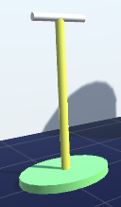 | Lever: Cubie can shoot the ball by this element.
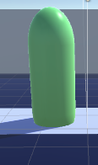 | Moving Object: Cubie can move this object. The ball is bounced at this object.
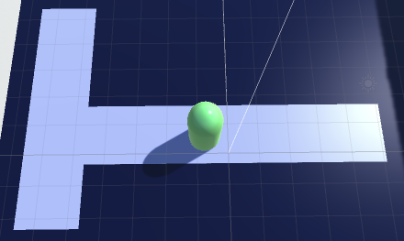 | Guideline Path for Moving Object: It constraints movement of moving object. Cubie can move moving object within this guideline path.
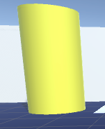 | Non-moving object: Cubie cannot move this object. The ball is bounced at this object. One of this object shoots the ball by the lever.
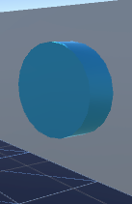 | Helper switch: This switch is for showing hidden object in the stage to help Cubie to solve the puzzle. It can be activated only by a ball, so Cubie need to push this switch with a ball. It can be place anywhere in the stage.
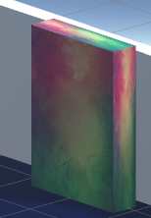 | Goal object: It is a object which Cubie need to hit with a ball to finish the level. It is represented as a rainbow box in the stage.

Game screen
The screen of this level consists of two text UIs, each one explains controls of player and a goal of this stage, and main stage for showing the level.
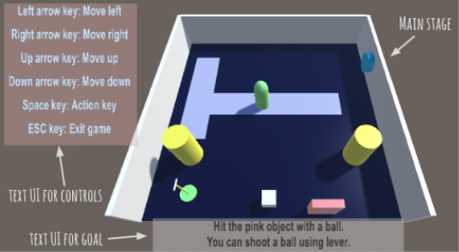

Level Design
Stage 1 consists of 3 levels.

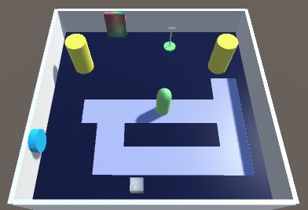 | Level 1: It is the easiest level of stage 1. Player can get familiar with various objects on the stage and have sense of solving the puzzle.  Elements:  Two Non-moving objects  One Moving objects  One Helper switch  One Hidden moving object
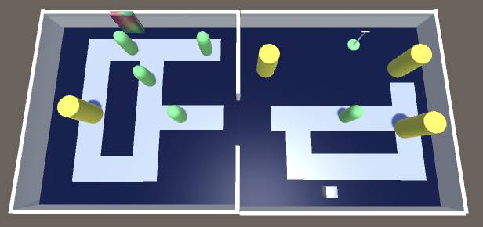 | Level 2: It extends from level 1. There are no helper switch. Since there are many moving objects and non-moving objects, player needs to think how to organize positions of objects so that the ball can hit the goal. Player need to be careful, because some object should not be used to win this level.  Elements:  Four Non-moving objects  Five Moving objects
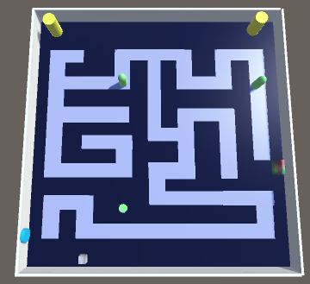 | Level 3: Size of the level is two times bigger than level 2. Now a maze is embedded in the level, so player needs to solve a maze to place moving objects in desired location. A maze is generated using search-based procedural content generation and modified so that puzzle elements like lever can be placed in desired position.  Elements:  Two Non-moving objects  Two Moving objects  One Helper switch  One Hidden moving object

Stage 2
This is a fast paced racing level. Cubie must dodge obstacles as he is propelled forward at a constant speed on an endless cylinder. The racing track is procedurally generated with various types of obstacles and interactive elements to provide an interesting, fun racetrack.
This level is focused on quick reactions more so than it will be logical thinking. In order to stay ahead Cubie will need to dodge obstacles and find powerups. At the end of the level Cubie is rewarded with the next piece of his transformation machine and he is returned to his home base.
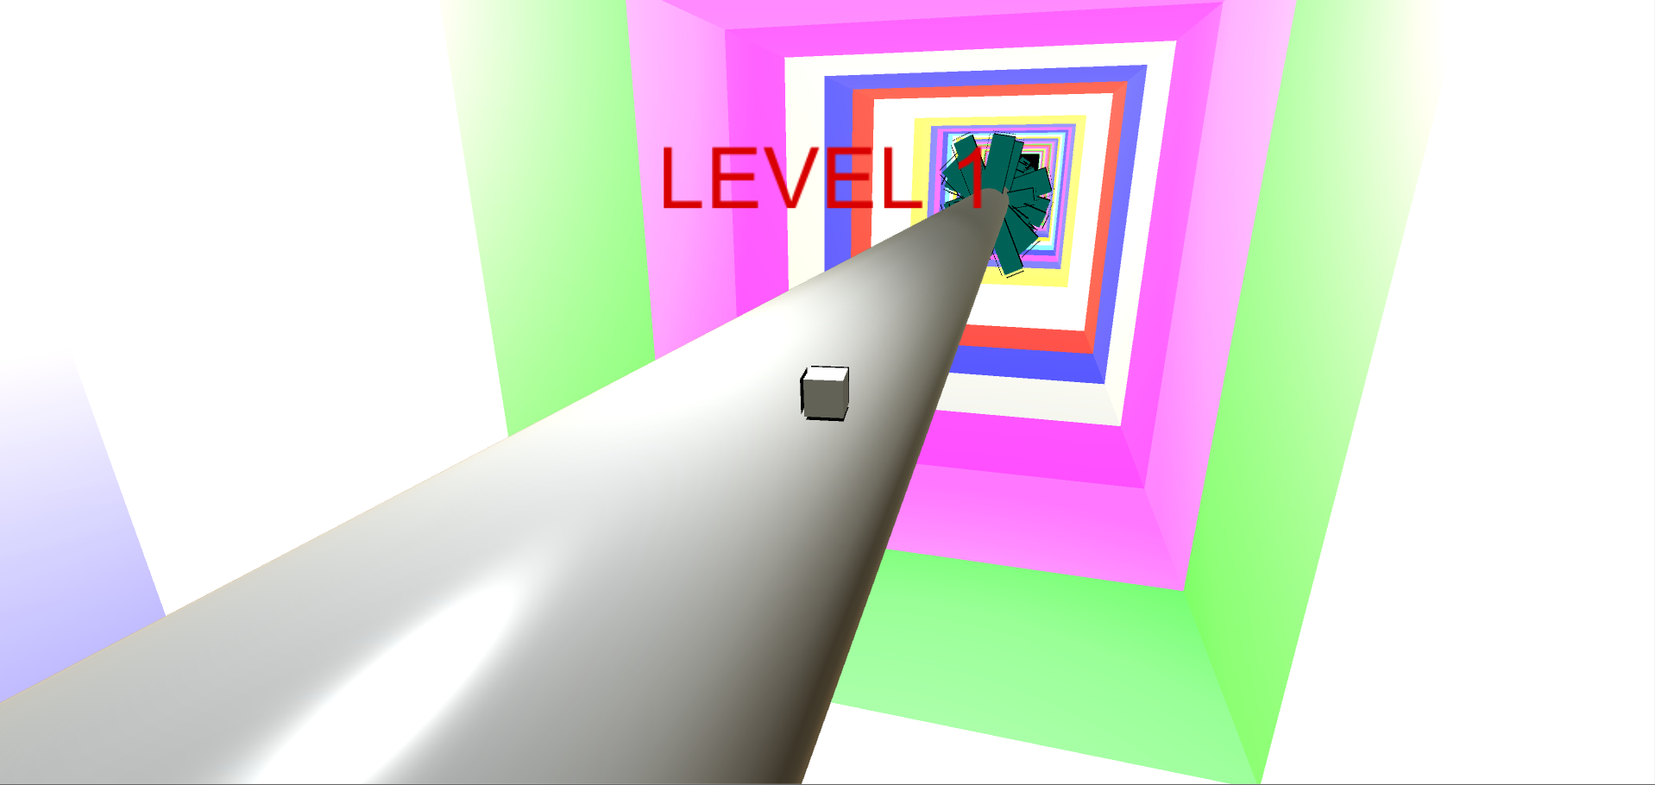
In this image cubie is just beginning his trek into the racetrack level. The racetrack is procedurally generated and can continue endlessly, but eventually will end after the player passes a threshold. The track is generated in sections to allow simple cleanup and creation. In the image, Cubie begins at the first section, which is empty to provide him time to become acquainted with the controls. There are a variety of “levels” in this gameplay mode, with each “level” corresponding to an increase in difficulty. As difficulty increases the spacing between obstacles becomes closer, Cubie may speed up, and obstacles may begin to rotate or move perpendicular to the racetrack. This makes gameplay much more interesting and challenging.
Cubie has a variety of forces keeping him stuck to the racetrack. The primary force acts perpendicular to the spot cubie is tangent to on the cylinder. This ensures that an obstacle does not push him off the track. Also, the force is proportional to Cubie’s distance away from the edge, which prevents clipping when he is at the edge but ensure he won’t ever stray too far away. Cubie dodges obstacles by rotating the track beneath him with the arrow keys. He is always kept centered at the top most portion of the track. If an obstacle pushed him away he will slowly return to his place. The camera remains a fixed distance behind him and obstacles shrink to nothing as they are passed, preventing user’s view occlusion.
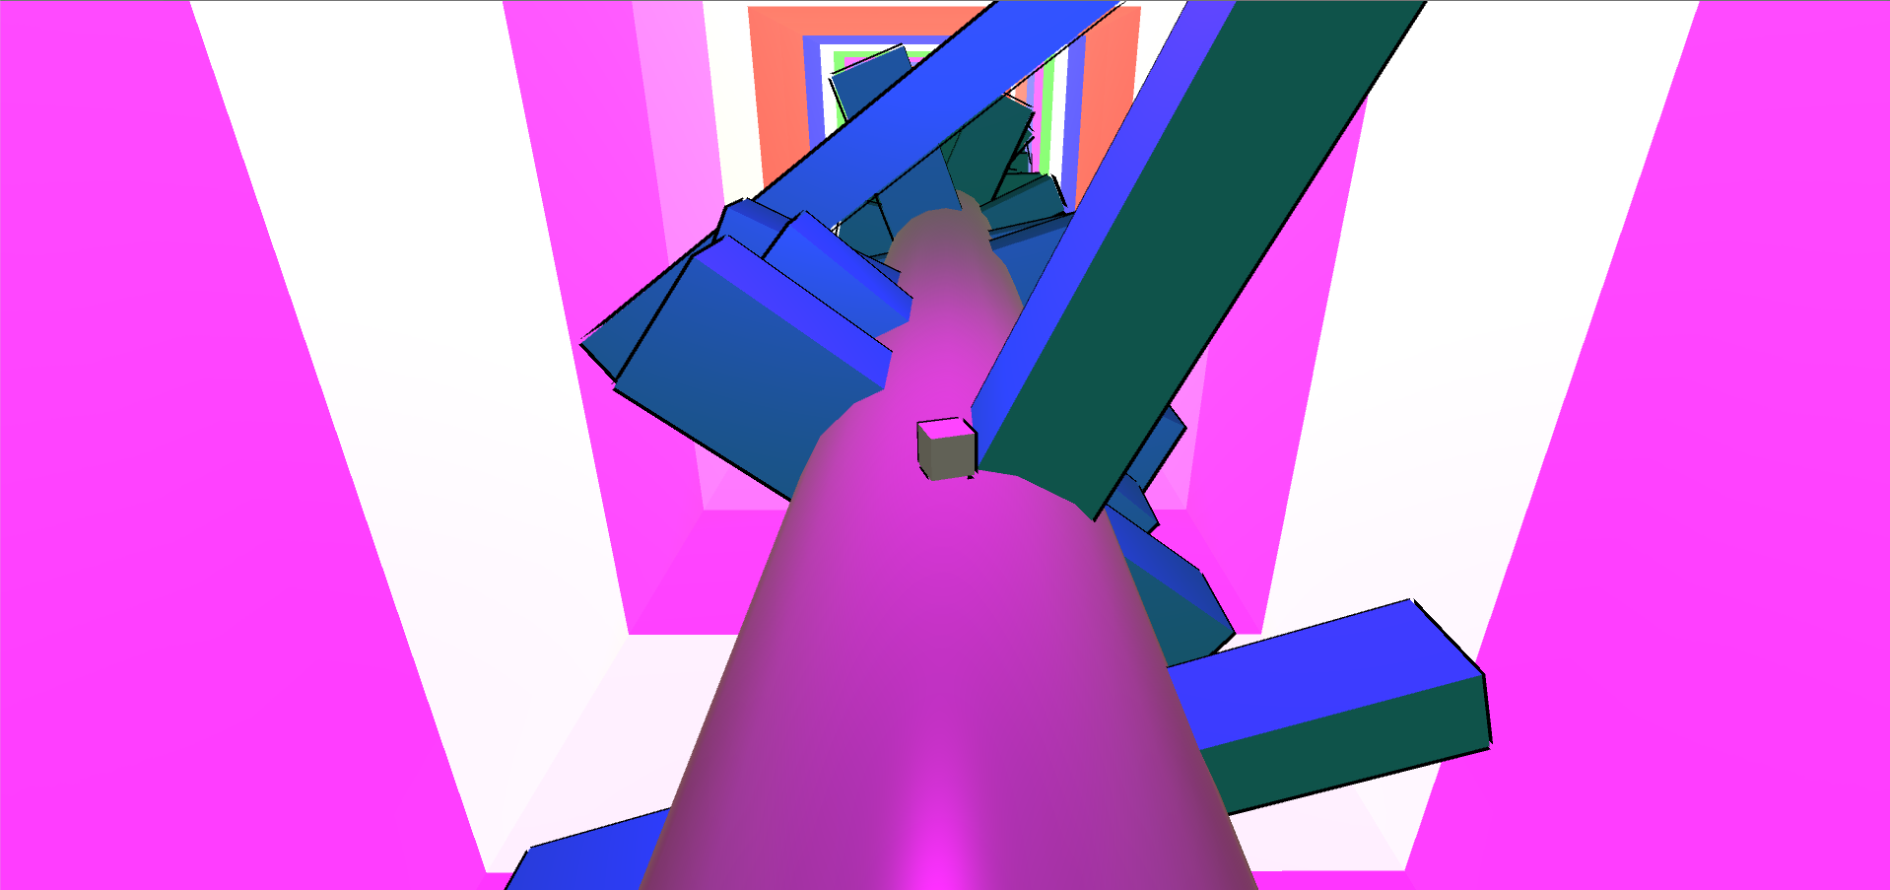
One interesting aspect of this level is the lighting. The walls are generated alongside the racetrack and are given a random emissive color value. Originally one light was placed in each wall section, but this had to be removed due to performance issue (too much dynamic lighting). Instead, a spotlight was added to the camera and pointed toward Cubie. As cubie moves into a new wall section his location is hashed into the walls array and the spotlight’s color is changed to the proper wall color.
Obstacles come in 4 types: large, small, moving, and rotating. Large and small obstacles are non-moving with widths randomly created within a given range. The range for large obstacles is bigger than small obstacles which are created with more frequency. Rotating and moving obstacles are large/small obstacles that have had a movement script added to them. Rotating obstacles rotating around the cylinder in a tangential manner. Moving obstacles are created at a random orientation such that their midpoint is tangent to the cylinder, and they move perpendicular to the cylinder within given ranges. These obstacles add layered variety to the gameworld and more difficult obstacles will increase in frequency with gameplay.

Stage 3 - Elemental Conundrum

Design:

The third level of the game features a difficult logic puzzle that requires the user to observe their surroundings and come up with a valid solution in order to help them reach the exit door. The level has two main parts.

The first part of the level is a simple tutorial. The player must first realize that the exit portal is covered by fire that kills Cubie when touched. After searching around, the player will see that a platform of water is hovering above the fire and can be used to extinguish the flames. In order to release the water, the user must search for a button that is covered in a third element, sludge. The sludge is poisonous and can hurt (and eventually kill) the user and must be burned away using fire. The button covered in sludge is pictured below.

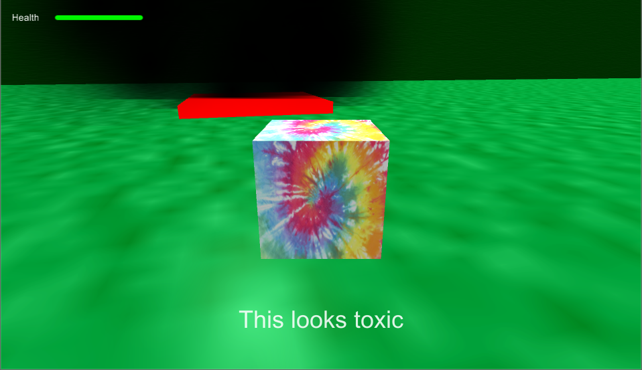

This allows the user to see what the button does in order to give them an idea of how to complete the level once they respawn. After searching through the level, a stick can be found that can be set on fire. Once set on fire, the user will have a limited time to burn away the sludge before the stick burns away. Once the sludge is burned away, the player can step onto the button, release the water and walk towards the exit portal. The exit portal in this part leads directly to the next room, which is the main logic puzzle of this level. Below is an image showing the player stepping on the button while watching the water extinguish the fire that is covering the exit portal.

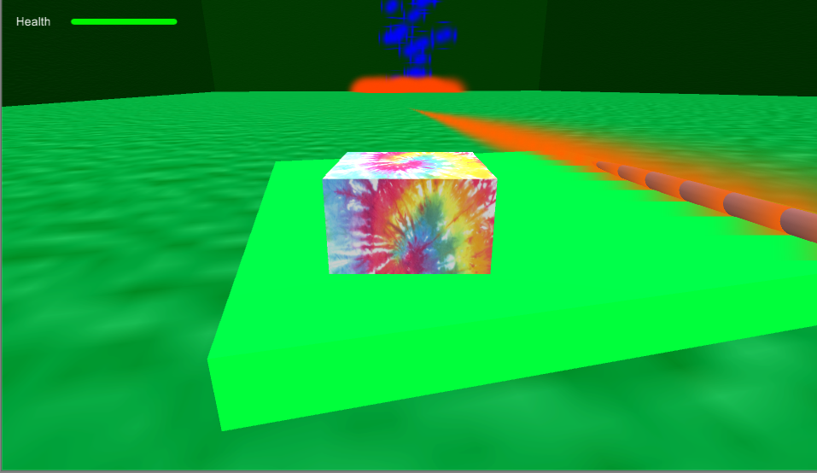

The second part of the level is the main logic puzzle. Here, the user must search around and find a way to utilize the different abilities of the three elements in order to overcome all obstacles and reach the final doorway. Upon entry, Cubie will encounter a wall of sludge that emits a poisonous gas. Running into the sludge barrier will hurt and eventually kill Cubie.

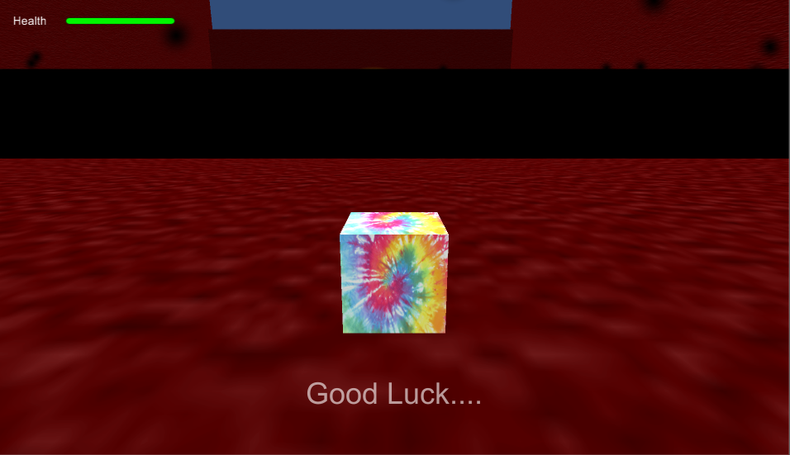

In order to get past the sludge, Cubie must complete the two side puzzles. The first side puzzle features a code-cracking challenge similar to the game Mastermind. Every time the player presses “H”, Cubie is presented with three new cubes in the pool of water. Cubie most toggle the colors (by pressing “T”) of the cubes until the correct sequence is reached. After submitting a combination, the game will check to see if the cubes represent the right code and may respond by lighting up certain cubes. A gold light tells Cubie that the specific color chosen in that column is in the right place. A white light tells Cubie that the color in that column is part of the Code, but the color it is in is not the right column. An example response is pictured below.

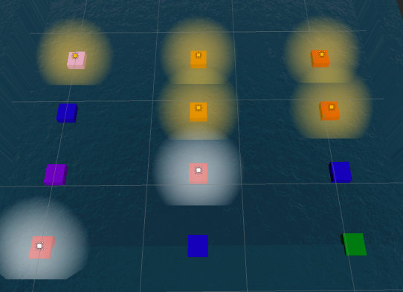

Getting an answer wrong generates a fireball storm in random spots in the pool. Both the fireballs and resultant steam can hurt Cubie. Cubie has 10 tries to crack the code and each wrong answer hurts Cubie a little more. If the code is found, Cubie can proceed to the back of the pool to complete the first part of the level. In the back of the pool, there is a button that, when pressed, turns on the fire emitters in the middle star, which is shown to the player by switching temporarily to an overhead camera. After the “cutscene”, Cubie will be positioned at the beginning of the pool and resupplied with full health.

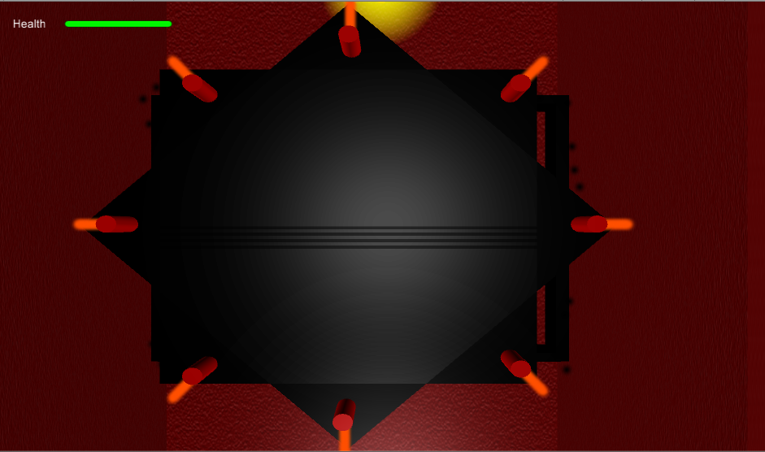

Next, Cubie must enter the second room, whose door is now open, and complete the final part of the puzzle. The second part has a desert theme and consists of a randomly generated maze featuring walls that only appear as Cubie approaches them. When inside the maze, Cubie can press “C” to enter an overhead view mode to better see the maze. Scattered between the walls are purple spheres called Sphere Wizards that shoot sludge projectiles at Cubie. Each Sphere Wizard has a chance of having a homing projectile that will follow Cubie around the maze until either it is destroyed by running into a wall or it burns away. Pictured below is an example of a few Sphere Wizards shooting sludge projectiles in the direction of Cubie.

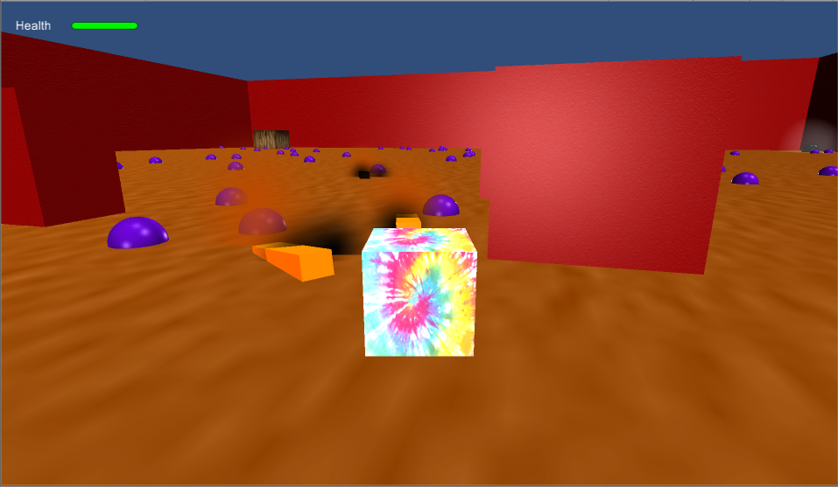

Hidden within the maze is a sludge powerup that Cubie can equip to protect himself from the projectiles. Once Cubie learns his way around the maze, he must trick the Sphere Wizards into helping him destroy the wooden box (always spawned in the top right corner) to reveal the hidden button underneath. This is possible as the projectiles are shot in the direction of Cubie. Simply standing in front of an enemy and dodging the projectile at the right time will make the projectile collide with the box and destroy it. However, this is not always easy as Cubie must first clear any walls in the way, by having projectiles destroy them, which can leave him vulnerable to attack. The player must control Cubie and think about their movements in order to destroy the box without having Cubie die. Pressing the button does not leave Cubie safe; Cubie can die while either leaving the maze or watching the cutscene. The player must either find a safe spot for Cubie to stand, or make sure the sludge powerup is equipped.

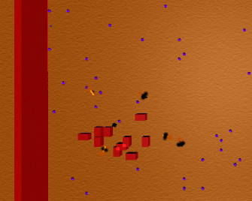

Pressing the button from the maze portion of the level lowers the middle star and burns away the sludge ring. After the sludge is clear, Cubie can proceed to the end of the level and exit. Finishing this level will give Cubie a part of the overall transformation machine that he can bring back to the main room.

If Cubie dies, an X will show up on each of the faces of his body and the player will be given the option of returning to the homebase or to try again.

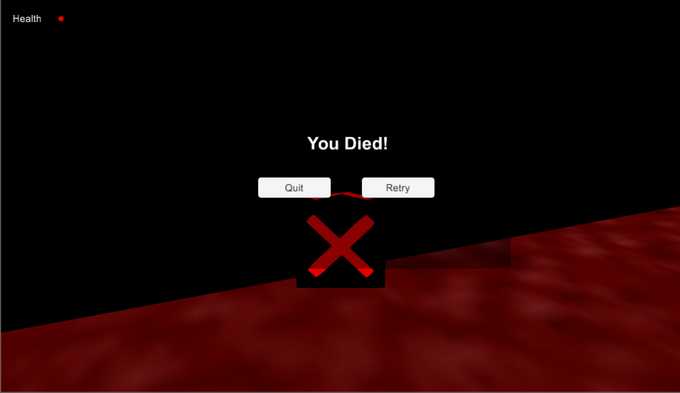

Implementation:

A majority of level 2 was implemented in a way that keeps the overall puzzles generic and easily expandable or changed if needed. Both the code breaking puzzle and the maze are randomly generated at run-time, giving the player a unique experience on each level load.

The code breaking game is based on a simple board game called Mastermind. We ultimately decided to use three columns for the code, but the game is designed to handle any number of columns and size and place the buttons within the pool accordingly. The code is generated randomly at run time and can consistent of any combination of colors from a pre-determined list. After every response from the player, the previous row is checked for correct response and deactivated from the user's control. First, the row is checked for correct responses and labels the correct columns with a gold light. Next, the row is checked for responses that aren’t gold, but use a color that is part of the code. Columns with the correct color but not in the right position are labeled with white lights. Using logic and process of elimination the player can eventually reach the code. Each time (up to 10) the player fails to get the code, particle effects made to mimic fireballs are randomly generated to drop within the bounds of the pool. The pool is tagged with a water tag, which allows steam to instantiated when a fireball, with a fire tag, collides with the pool. The steam spawns in place and disappears after a few seconds. It is highly unlikely that Cubie can fail all 10 times and still live as his health is reduced by a fraction of his health every time. Combined with the fire ball and steam damage, it is unlikely Cubie can fail the puzzle and live. If he does, the level can be restarted.

The maze portion of the level is randomly generated and can be tuned by changing various parameters including number of columns, number of rows, enemy spawn likelihood, wall rotation likelihood and wall spawn likelihood. The maze exists in the middle of four walls, creating lateral and vertical limits on the maze. The limits are measured and a grid is created according to the number of columns and rows, both of which are generated randomly at run time. For best results, the number of columns and rows is limited to values between 10 and 30 for the maze size chosen in this game. Once the grid is created, spawn points are placed at each point in the grid and stored within a 2d array. The algorithm first goes through the array and picks specific positions to be walls, based on the wall likelihood parameters (each point has a wall_likelihood% chance of being a wall). Then, if a wall is spawned, it will have a rotation_likelihood% chance of being rotated 90 degrees. Walls spawned are sized based on the lateral and vertical extremes divided by the number of rows or columns. This way, walls that touch meet at their corners perfectly and do not overlap in a way that is not perpendicular. Any point that does not have a wall has an enemy_likelihood% chance of being enemy. When an enemy is spawned, it has a 25% chance (hardcoded) of being a level 2 enemy, allowing it to shoot homing projectiles. The inclusion of all of these parameters allows the maze to be fine tuned in a way that the level is still beatable, while avoiding the redundancy of a scripted puzzle.

Collisions in this level are done with colliders and tags. Early on, definitions for which tags should react with others were made and the rest of the level was built around these concrete rules. For example, systems were built for fire to react with water to create steam, and later, fireballs were just tagged with fire and reacted with any water source to create steam. This is also the case with the sludge particles in the level. When Sphere Wizards launch sludge projectiles, they move because adding fire to a sludge projectile applies a force in the direction of its forward vector. This allows homing missiles to work easily by having them look in the direction of the player at all times. The projectiles also have the ability to react with other sludge bricks and set fire to them through contact, but this functionality was not used in the final implementation of the game.

Stage 4 - Aspiration to new Heights
This level is a slower, somewhat more adventurous level. Rather than covering horizontal distance, this is all about scaling to the top of a tower, along with many obstacles along the way. The first level will likely be a sliding block puzzle to push different shaped blocks (mostly ones with five, six, or seven sides) into their required spots; very simple and the puzzles get more intricate from there. The second puzzle will require platforming with wind as an obstacle. After leaving the second room, a series of treasure chests must be unlocked in a specific order to find the way to the third room, which is found in the next scene; this strategy is the general idea. There will be a total of six or seven rooms.

Elements of the stage
Currently, these are the basic kinds of elements to be seen.
Cubie: This is the main character to be controlled.

Signpost: These can be viewed for reference or hints or story.

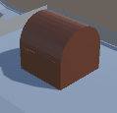 Treasure Chest: One of the different kinds of assets that can be interacted with to make progress in the stage.

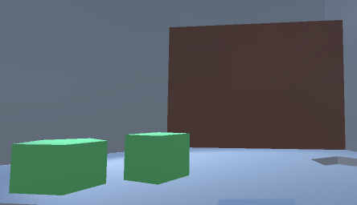 Door (with puzzle elements): Each internal room, and parts of outside rooms, are blocked by a door, which will look similar for each instance of it. The puzzle elements here are interacted with to achieve the goal and to finish a specific puzzle which is in the way of progress.

Motivations for this level remain unclear; there is something at the top of the tower that may be useful or required for Cubie’s story. It may even be near the end of the main storyline and after this, Cubie reaches some teleportation device, some plot device power, some plot device technology, or some game breaking event one way or another. This does not have to be the level, but if this level becomes grandiose enough, it can be if that is agreed on; it may be the level that tests the character emotionally the most, or something other.
At some point after scaling the tower enough near the top, the scenery changes entirely and becomes grandiose, such as including floating platforms, requiring careful platforming to not fall off. At this point, various power-ups, hints, and obstacles from before, will show themselves again and everything learning escalating throughout the tower will prove itself useful for one last struggle.

Game screen
The screen of this level contains general text information the player can view to know where they are at in the stage.

Top-Left: This denotes the current section of the tower Cubie is in, and a notice that this is in Level 5. The term “Level 5” will be replaced with the full working title of the level.
Top-Right: Inventory carried in stage at given time. This may contain items or keys found from varying rooms, treasure chests, or other locations.
Bottom: This shows up near specific points of the stage that require input to progress, such as near a sign that shows you to press a certain button or action to read the sign. This disappears when it is no longer possible to read from the sign, or whatever the condition was.
Center: If a message is brought up, such as through reading a sign or a message has been said by another entity, the center of the screen will contain a block of text the player can read to give them clues, or general notice as to what is being said.

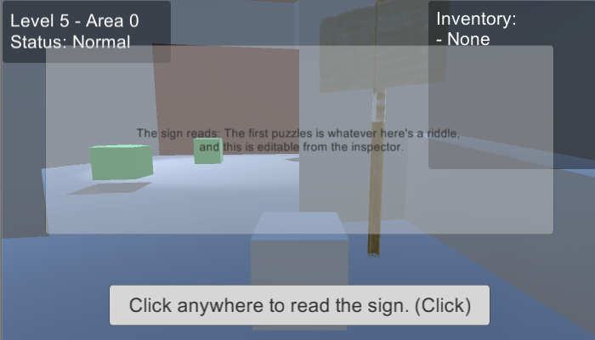

Stage 5 - Which way is up?
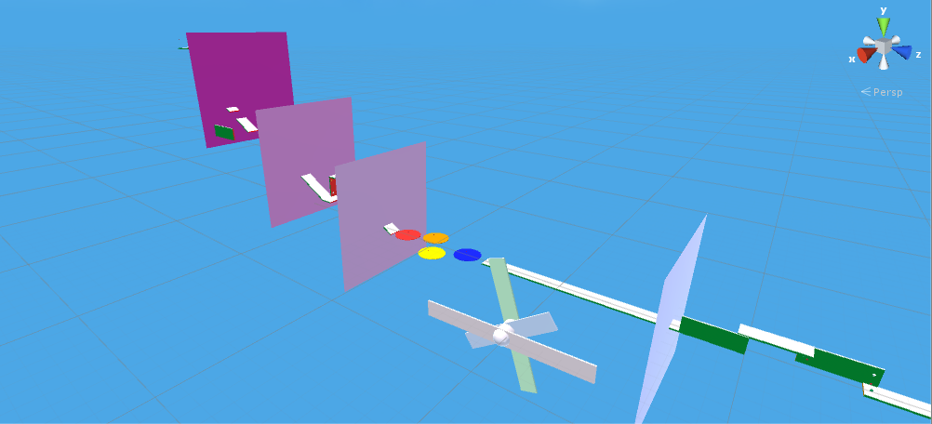
Design
In the final stage of The Legend of Sphera, Cubie has used the power of the machine to transform himself into a sphere. Cubie finds himself in a room with a single gem. Once Cubie picks up the gem, a blockade is removed and the player can progress. The level is broken into zones where a certain number of gems are needed to progress to the next stage. Each stage implements different challenges. The distinguishing challenge is the need to manipulate gravity in order to traverse “walls” and “ceilings,” rotating the camera to appear the the old “wall” is the new “floor.” Beyond this there are wind forces, rotating platforms, and platforming challenges mixed together. The player also receives an upgrade after reaching a certain point.

Before After
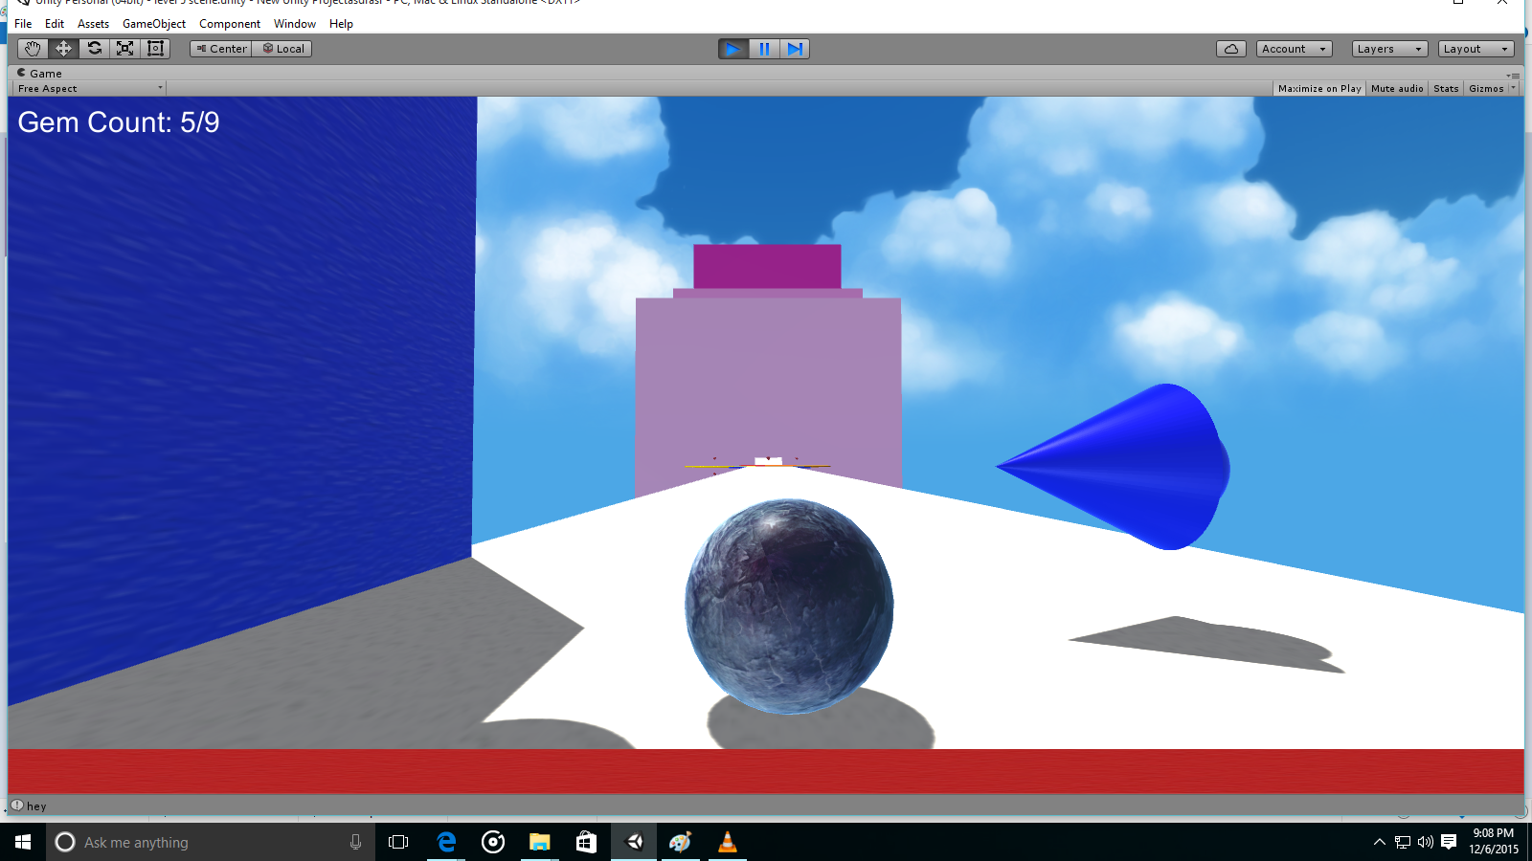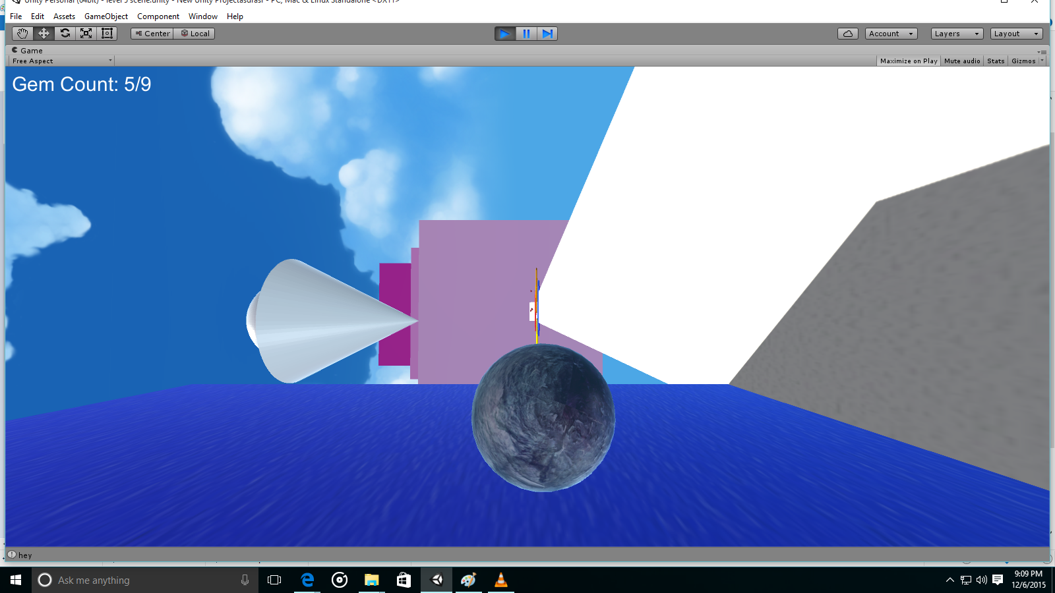

Objects
- Cubie
- Grav Rotator
- Fan
- Rotating Platform
- Gem
- Double Jump

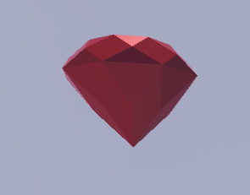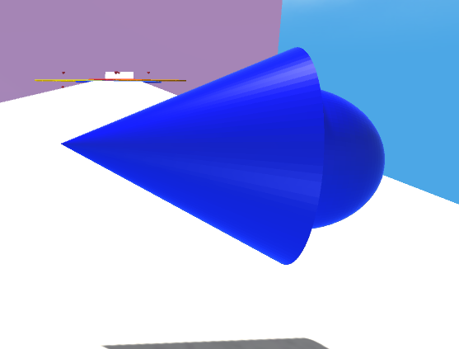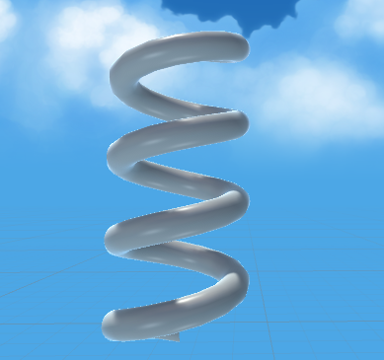

Implementation

The level plays as a state-dependent platformer. At this stage of the game, Cubie has transformed into a sphere. When the player presses a “move” key, a combination of forces move cubie in that direction. That main force that movies cubie is torque, with the movement keys applying it in necessary directions. This allows smooth rolling and momentum in all directions. Beyond this main force, a much smaller directional force is added as well. This primarily allows the player some small movement while in the air, which makes platforming more playable. This small force secondarily adds to small stability improvements. The jumping is accomplished by using an “upwards” velocity change. This allows for better and more intuitive jumping as opposed to a simple direction force.

When the player activates a grav modifier, the state of how the physics work changes based on which direction the grav modifier is directed at. the camera then snap rotates to coincide with the modified physics. The actual gravity is redirected in the correct + or - x,y,z direction accordingly. The player controls then update to keep the movement as it should, changing the direction of the torque, directional force, and velocity change. The camera is then altered to coincide with the gravity where “up is up and down is down.” This system allows for intuitive, logical control over Cubie. Despite the directional gravity or camera rotation. These effects are then attached to gameobjects that are color coordinated to help navigate the terrain as needed. Jumping is controlled by implementing various “is_grounded” and “has_jumped” checks to allow for initial single jump and once the player reaches the needed pickup, double jump. This again works correctly despite the current gravitation direction. Custom-made textures and models were added to give the game a rich aesthetic feel. There is also a respawn system based on progress through the level. Various sci fi sound effects are added when the player does something meaningful as well as a grand theme played in the background. There are also UI elements to displace gem count progress and power ups being available.

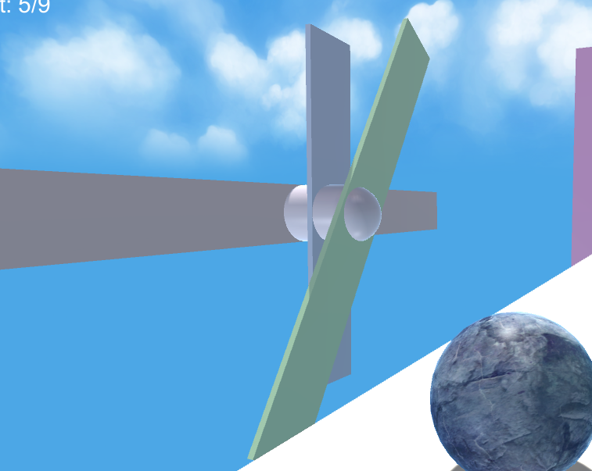

The main challenge comes from platforming skill but there are other challenges that arise from the environment. One instance of this is a large fan object that will push Cubie away from it with the force being the strongest directly in front of it and weaker as to get further from the center of the fan, as it would in real life. There are also rotating platforms the player must traverse that can counteract of speed up the rolling effect depending on whether cubie is rotating with or against the platform.

Credits

Team Geotronics - The Legend of Sphera
Taumer Anabtaw – Level 3
Jessica Kasson – Level 4
Paul Kim – Level 1
James Lowrey – Level 2
Bob Tishma – Level 5
Bethesda Studios - Morrowind Theme
Blastwave FX - Sci-Fi Sound FX Pack
G.E Team Dev - Fantasy Skybox FREE (Asset Store)
Nexon Maplestory - Remebrance, Plant Zone (Soundtrack)
Nintendo, Zelda Skyward Sword - Earth Temple (Soundtrack)
Square Enix, Final Fantasy 7 - Prelude
Square Enix, Final Fantasy 7 - In search of the man in black from
Rod Stewart - Have I told you lately
Valve, Portal 2 - 99999999 (Soundtrack)
Vinicius Marques - 3rd Person Controller + Fly Mode (Asset Store)
Racetrack sound effects - FreeSound.org users copyc4t, LittleRobotSoun, LittleRobotSoundFactory

